ICS 103: Computer Programming in C
Second Semester 2011-2012 (Term-112)
Lab 1: Introduction

Objectives:

- Learn basic components of a C program.
- Learn the compilation process.
- Learn how to use Dev C++.
- Learn how to write, compile, and run simple C programs.

A C-program:
A typical structure of a C program consists of:
- Preprocessor Directives that always begin with #
Example: #include <stdio.h>
The two most frequently used directives are #include and #define.

#include directive will include header files that have the definitions of functions used in the program.
Example: printf function is defined in the header file stdio.h

Note: #include <file> tells the compiler to look for file where system include files
are held
#include "file" tells the compiler to look for file in the current directory where
the program was run from.

#define is used to replace a text with a value, e.g. #define PI 3.141593
- Functions
A function is a block of statements that perform a specific kind of processing.
Every C program has a main() function. The program execution starts from
main().
- Variables / identifiers
These are used to store data in a program. You must declare a variable before you
use it in a program.

The general structure of a C program is:

peprocessor directives  main function heading  {  declarations  executable statements  } | #include <stdio.h>  int main(void)  {  printf(“hello World”);  return 0;  }

Note: The above program has no declarations; because it does not use variables
Compilation Process: The process of converting a source file (Example: A C program) into a machine language program
Source File
Compiler
Error message
Object File
Unsuccessful
Successful
Linker
Other Object Files
Executable File

The following are the steps to write, save, compile, and execute a C program in Dev C++:
1. To write a new program use the menus File → New → Source File

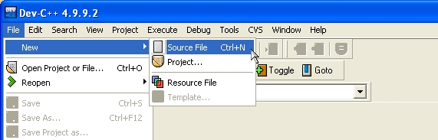

2. Write the new program. Example:

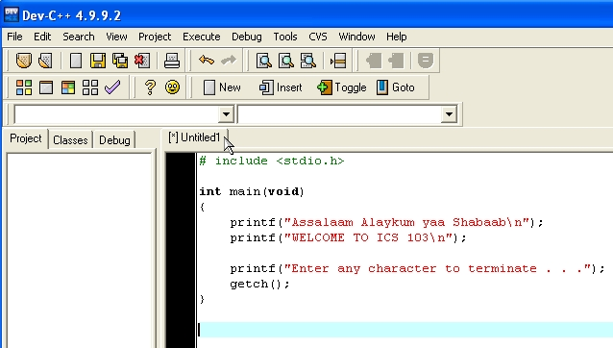

Note: If the program is not saved, [*] appears before the default name given to the program; in this case the default name is Untitled1
2. Save the program using the menus File → Save As 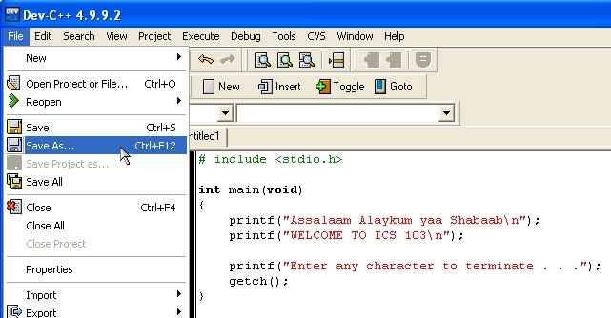

Change the default name Untitled1 to a meaningful name and with the extention .c Choose an appropriate folder to save the program:

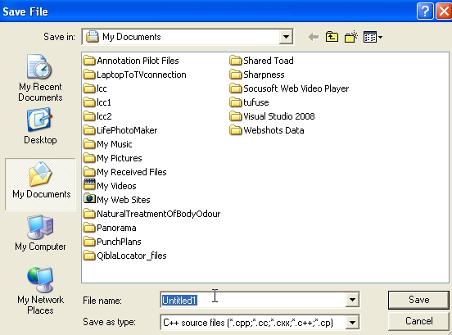

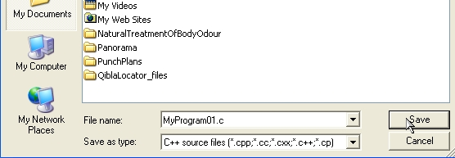

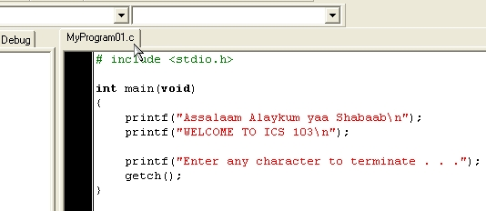

3. To compile the program use the menus Execute → Compile

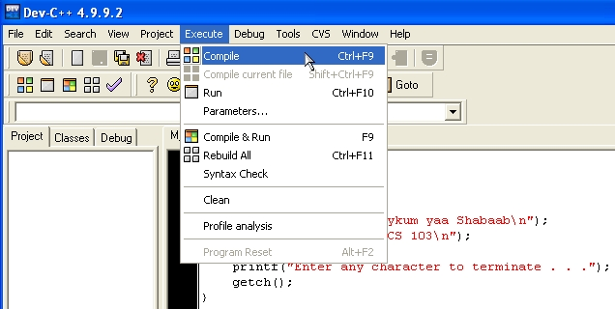

If the program has no syntax (grammatical) errors, the following Compile Progress box appears:
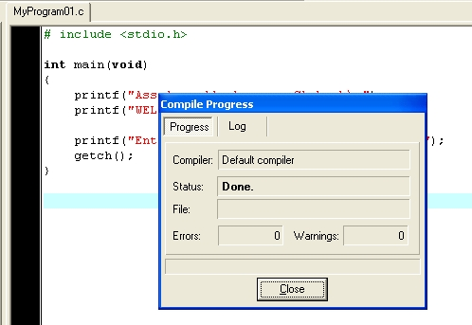

otherwise the compiler will show error messages.

4. To execute (or run) the program use the menus Execute → Run
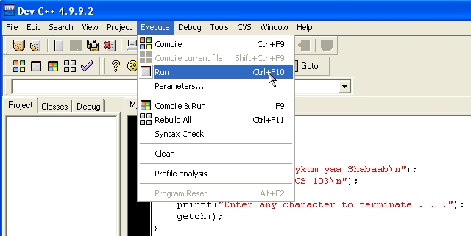
The output for the above program is:
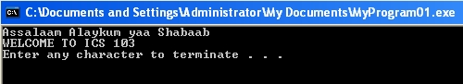
Some C Programs:
Program 1: find multiplication of two numbers:
#include <stdio.h>
int main(void) /* function main begins program execution */
{
int num1,num2,result;
num1 = 15;
num2 = 20;
result = num1 * num2;
printf("%d * %d = %d\n", num1, num2, result);
printf("Enter any character to terminate . . .");
getch();
return 0;
}
Program 2: print a number and its square:
#include <stdio.h>
int main(void)
{
int num,square;
num=50;
square=num*num;
printf("The number It's Square\n");
printf(" %d %d\n", num, square);
printf("Enter any character to terminate . . .");
getch();
return 0;
}
Program 3: convert from Celsius to Fahrenheit:
#include <stdio.h>
int main()
{
/* fahrenheit =32+9/5*celsius */
double celsius , fahr;
celsius = 70.0;
fahr = 1.8 * celsius+32;
printf("Fahrenheit: %f Celsius: %f\n", fahr,celsius);
printf("Enter any character to terminate . . .");
getch();
return 0;
}
Program 4: Area and Circumference of a circle:
#include <stdio.h>
# define PI 3.14159
int main()
{
double radius, area, circumference;
radius = 5.0;
area = PI * radius * radius;
circumference = 2 * PI * radius;
printf("Radius = %f cm\n", radius);
printf("Area = %f square cm\n", area);
printf("Circumference = %f cm\n", circumference);
system("pause");
return 0;
}
Lab tasks:

Launch Dev C++ in your computer then write, save, compile, and run each of the above programs. Use meaningful names for your programs. USE THE EXTENSION .c AND NOT .cpp FOR YOUR PROGRAMS

